Add Product

Get Order

Details

Register User

Update

Product Delete Product

# Admin

User

Login logout

Update Profile

Add to Cart

Remove from Cart

View Reports

Calculate Discount

Extend

Get Product Details

-in-clu-de------------

include

Calculate Total

Verify Payment

# system

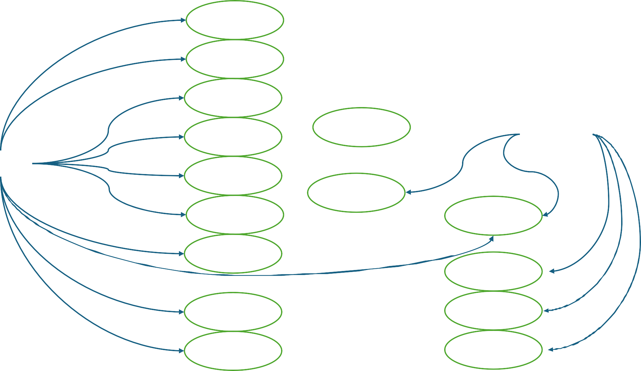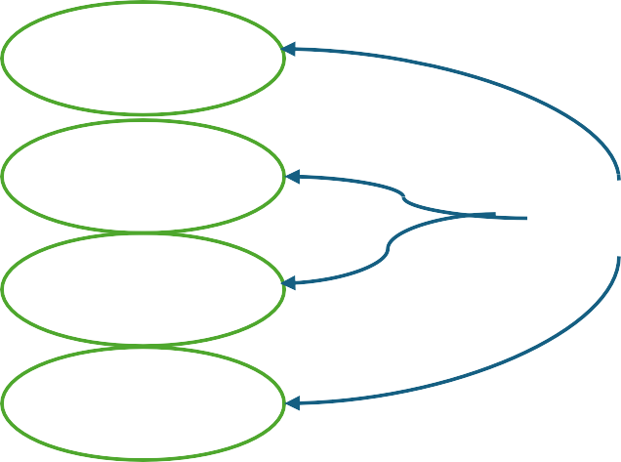

Cancel Order Place Order

include

Update stock

include

Refund Payment

Process Payment